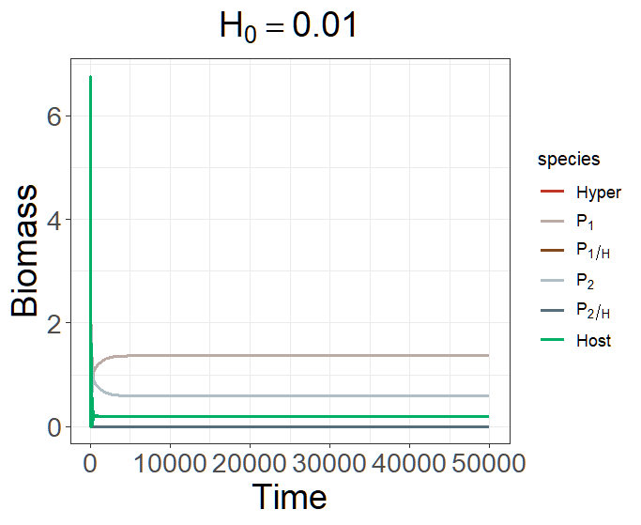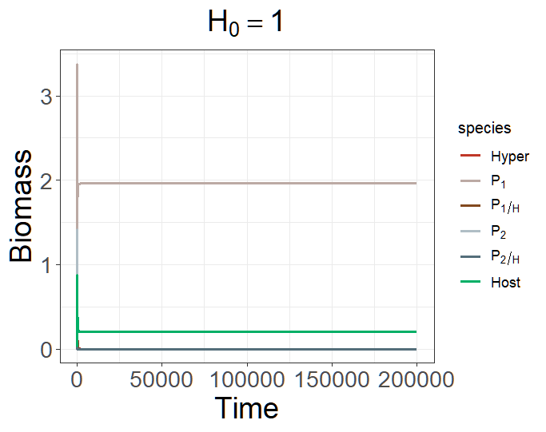
state <- c(H = 0.01/1, P1H = 0, P2H = 0, P1 = 0.01, P2 = 0.01, S = 0.2)
parms <- c(r = 1, K = 10,
+ a1 = 0.5, a2 = 0.5, R1 = 1, R2 = 1, e1 = 0.5, e2 = 0.5,
+ b1 = 0.3, b2 = 0.45, m1 = 0.05, m2 = 0.05, e1H = 0.5, e2H = 0.5,
+ o1 = 0.8, o2 = 0.8, h1 = 1, h2 = 1, c1 = 0.9, c2 = 0.9, d = 0.03, DL = 0)

Alternative stable state
When H is large and α₁ = α₂, P₂ will be excluded because of H is too large

